

TASCO Motor Insurance Growth Platform · TGP-UX-03
Information Architecture and Navigation
Date – 08 October 2026
Version – 1.0
Prepared by – iorta TechNXT
TABLE OF CONTENTS
1. Document Control 3
2. Acronyms 3
3. Introduction 4
3.1. Purpose 4
3.2. Scope 4
3.3. Audience 4
3.4. Related documents 4
4. Surfaces 4
5. Staff console shell 5
5.1. Sidebar groups 5
5.2. Breadcrumbs 6
5.3. Global search 6
5.4. Notifications 6
5.5. Help and user menu 6
5.6. Site map 7
6. Navigation by role 8
7. Screen inventory: staff console 9
7.1. Detail views 10
8. Customer app 11
8.1. Structure 11
8.2. Renewal paths 13
8.3. Purchase flow 13
8.4. Claim wizard 15
8.5. Account 15
9. Hosts 15
10. Deep links 17
11. Key task paths 17
11.1. Customer renews from a reminder 17
11.2. Compliance officer handles a data request 18
11.3. Telesales agent works a handoff 18
11.4. Rule author changes a setting and an approver activates it 19
12. Appendix 19
12.1. Customer app screen inventory 19
12.2. Page names in both languages 19
13. Sign-Off 21

Document Control

Date | Version | Author & Business Unit Info | Reviewed By & Business Unit Info | Approved By & Business Unit Info | Change History
08/10/2026 | 1.0 | iorta TechNXT  Business Analysis and User Experience | TASCO Insurance  Product Owner | TASCO Insurance  Programme Sponsor | Initial issue for submission

Acronyms

Acronym / Symbol | Definition / Meaning
API | Application programming interface
KPI | Key performance indicator
QR | Quick response (code)
SLA | Service level agreement
SSO | Single sign-on
TNDS | Compulsory motor third-party liability insurance (Bảo hiểm TNDS bắt buộc)
UAT | User acceptance testing

Introduction

Purpose
This document describes where everything lives in the TASCO Growth Platform and how people move around it: the staff console shell, the navigation each of the 13 staff roles sees, the inventory of screens, the customer app with its tabs and task flows, what changes when the app runs in a different host, and the deep links that open a given screen.

Scope
The staff console, the customer app and the public certificate check, as delivered for user acceptance testing. The partner API has no user interface and is covered by TGP-MAN-03. Persona journeys, emotional curves and service blueprints are in TGP-BUS-06 Personas and Customer Journeys; this document covers only the screens and the paths between them.

Audience
The TASCO product owner and business leads, who confirm the navigation; designers and engineers who add screens; trainers and testers who need the map of the product.

Related documents
ID | Title
TGP-BUS-06 | Personas and Customer Journeys
TGP-UX-01 | Design System
TGP-UX-02 | UX Standards and Accessibility
TGP-MAN-01 | Staff Console User Manual
TGP-MAN-02 | Customer App Guide
TGP-ARC-04 | Security Architecture

Surfaces
Surface | Address | Users | Sign-in
Staff console | / | TASCO and VETC staff in 13 roles | Username and password; two-step verification for privileged roles
Customer app | /app/ inside a host app or browser | Vehicle owners | Signed link from the host; no password
Certificate check | /verify/<certificate number> | Anyone, for example traffic police scanning the QR code | None; shows no personal data
Partner API | /api/partner/… | Bank, showroom and agent systems | API key (TGP-MAN-03)

Staff console shell
Every console page sits in the same frame, so a user who knows one page knows where everything is on the others. The design of each element is in TGP-UX-01; how to use it is in TGP-MAN-01.
Element | Position | Contents
Utility strip | Top, full width, brand teal | Hotline 1900 1562; UAT badge in the test environment; EN / VI switch; user menu
Top bar | Under the strip, white | Menu button on narrow screens; breadcrumb; global search; notifications; Help
Sidebar | Left | Wordmark and “Growth Platform”; pages grouped by business area; collapse control
Page | Centre | Page header, optional KPI strip, cards on the 12-column grid
Footer | Bottom | “© 2026 TASCO Insurance · Powered by iorta TechNXT · v1.0”

Sidebar groups
Pages are grouped by what the business does, not by system module. A user sees only the pages their role allows; a group with no visible page is not shown at all.
Group | Pages | Badge
(no group) | Dashboard, shown as “My work today” for telesales agents
Sell | Leads, Telesales inbox, Voice assistant | Telesales inbox: new hot handoffs
Engage | Journeys, Campaigns
Serve | Claims | Claims within two hours of, or past, their acknowledgement deadline
Partners | Partners
Data | Data quality | Open data issues
Governance | Business rules, Approvals, Audit, Data requests | Approvals: changes this user may decide. Data requests: requests due within 24 hours or overdue
Administration | Users, Operations
Customer 360 has no sidebar entry. It opens from Leads, the telesales inbox, Data quality, Claims, Data requests and the global search, and the sidebar keeps Leads highlighted while it is open. For compliance officers its More actions menu links back to the customer’s data requests and to logging a new one.

Breadcrumbs
The breadcrumb in the top bar shows the group and the page (“Governance › Approvals”). Detail pages add the record, with the parent page as a link: “Sell › Leads › 30E-949.35”. The Dashboard has no group and shows its name alone.

Global search
Roles that can view customers have a search box in the top bar (“Search plate or phone…”). It finds a vehicle by the first three or more characters of its plate, or by a full phone number, within the user’s region, and opens Customer 360. Names are encrypted and not searchable. The / key moves focus to the box from anywhere on the page.

Notifications
The bell appears for roles that have work arriving: telesales agents and supervisors (new hot handoffs), rule approvers and compliance officers (changes awaiting their decision), compliance officers (data requests due within 24 hours or overdue), claims handlers (acknowledgement deadlines due soon or breached) and data stewards (open data issues). Its badge counts handoffs, approvals, claims and data requests; each entry links to the page where the work is done. Counts are taken from the same lists the pages show. They refresh on every page change and after each action, at most every 30 seconds unless an action forces a refresh.

Help and user menu
Help opens a short panel for the current page in the user’s language. The user menu shows the user’s name, roles and data region, and holds the language (English or Tiếng Việt), the theme (Light, Dark or System), Change password and Sign out.

Site map
The diagram shows the console’s groups and the pages they hold, from sign-in to Customer 360.
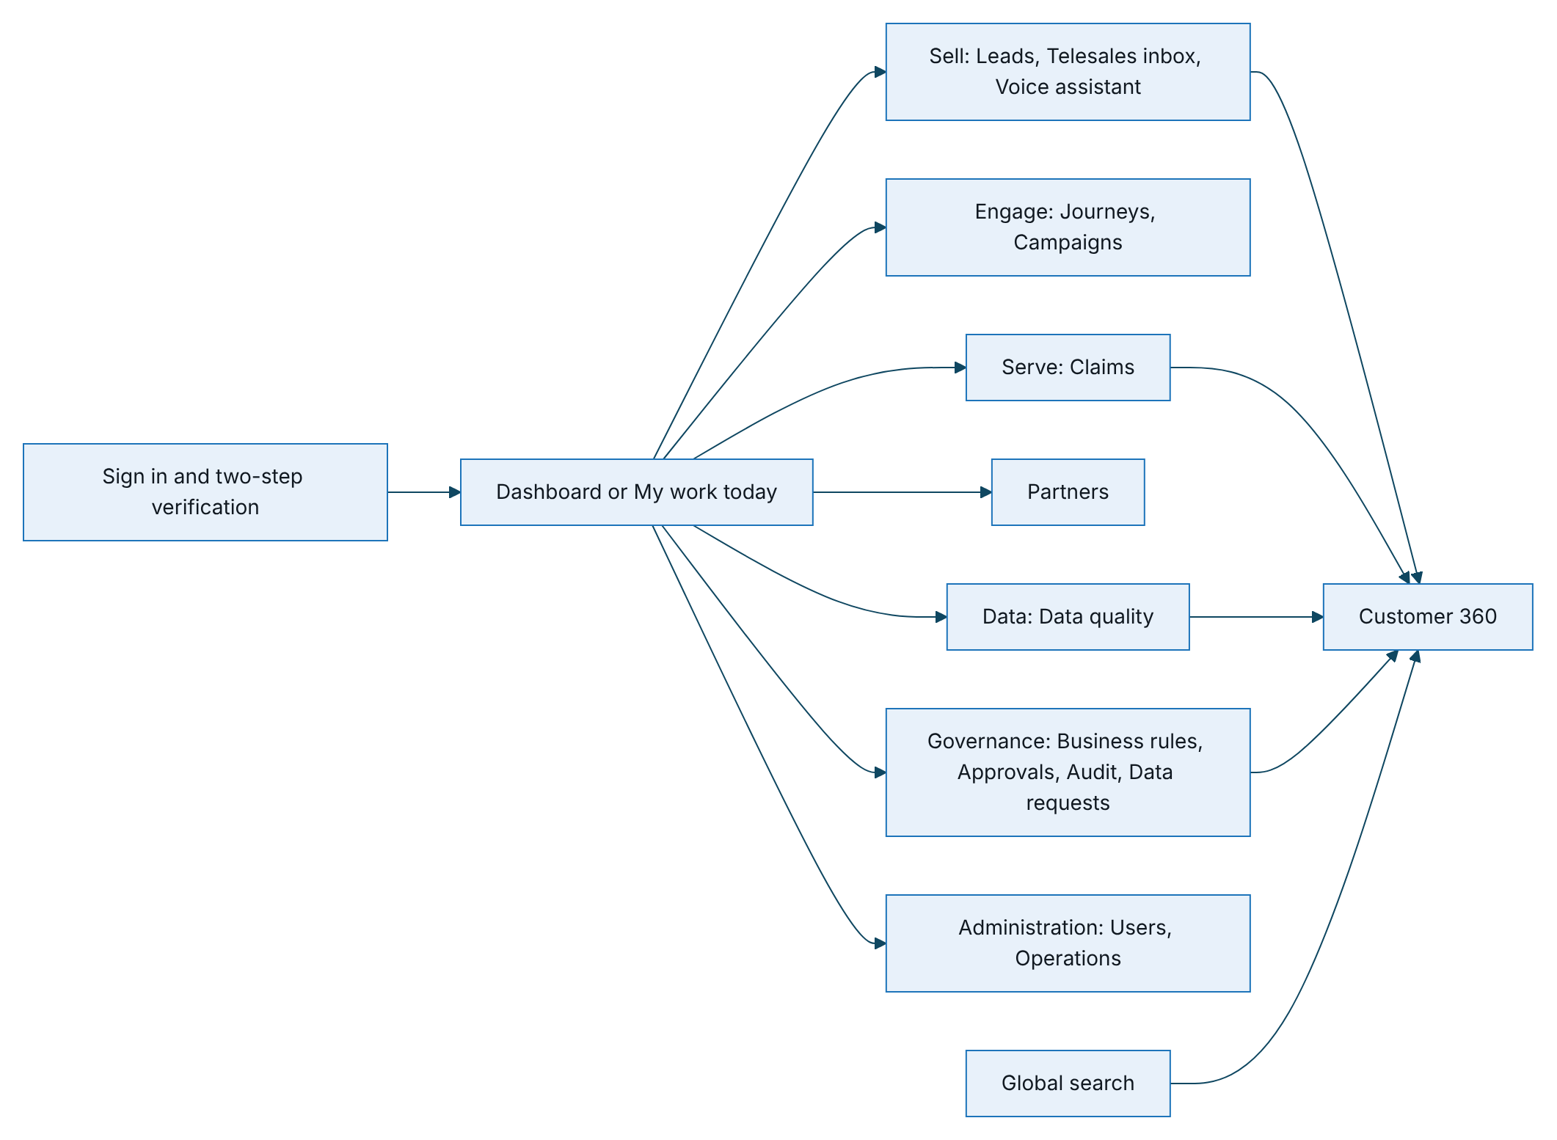
Figure 1 – Staff console site map, by sidebar group

Navigation by role
The console reads the user’s permissions at sign-in and builds the sidebar from them. The server checks the same permissions on every request, so hiding a page is a convenience and not the control. The roles and permissions are defined in the role configuration described in TGP-ARC-04.
Role | Start page | Sidebar | Search and bell
Executive | Dashboard | Dashboard | Neither
Campaign manager | Dashboard | Dashboard; Leads, Telesales inbox (read only), Voice assistant; Journeys, Campaigns; Business rules (read only) | Search
Telesales supervisor | Dashboard | Dashboard; Leads, Telesales inbox, Voice assistant | Both
Telesales agent | My work today | My work today; Leads, Telesales inbox, Voice assistant | Both
Rule author | Dashboard | Dashboard; Business rules | Neither
Rule approver | Dashboard | Dashboard; Business rules, Approvals, Audit | Bell
Compliance officer | Dashboard | Dashboard; Business rules, Approvals (including restricted rules), Audit, Data requests | Both
Data steward | Dashboard | Dashboard; Leads; Data quality | Both
Claims handler | Claims | Claims | Both
Partner manager | Dashboard | Dashboard; Partners | Neither
Administrator | Dashboard | Dashboard; Business rules (read only); Audit; Users, Operations | Neither
Support engineer | Operations | Operations | Neither
Auditor | Dashboard | Dashboard; Business rules (read only); Audit | Neither
- The start page is the first page in the sidebar order that the role may open.
- Telesales agents and supervisors see the leads, handoffs and customers of their own region; the others with access to customers see all regions unless their account is limited to one.
- A user with more than one role sees the union of the pages. Combinations that break separation of duties, such as administrator with any business role or rule author with rule approver, cannot be assigned.
- Opening a page that the role may not use, for example from an old bookmark, shows “You do not have access to this page.” inside the frame.
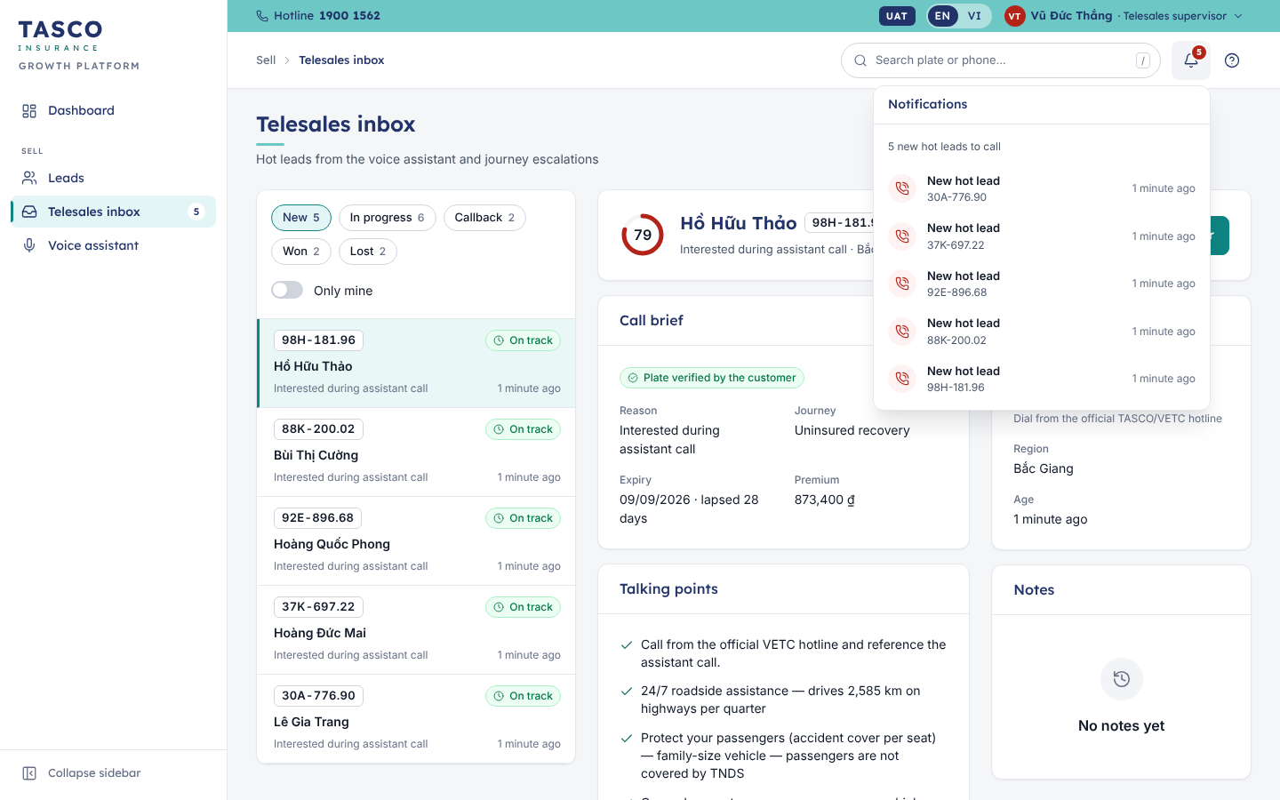
Figure 2 – Sidebar for a telesales supervisor, with the inbox badge and notifications

Screen inventory: staff console
Page | Route | Purpose | Roles
Dashboard | #/home | Role-specific figures, charts and worklists; “My work today” for agents | All except claims handler and support engineer
Leads | #/leads | Vehicles ranked by score with tier, journey, next best action and expiry; filters and export | Campaign manager, telesales, data steward
Customer 360 | #/customer/<id> | One vehicle and owner: overview, policy and quotes, data and sources, journey, contact history, activity | Every role that can view customers
Telesales inbox | #/handoffs | Queue of hot handoffs beside the selected handoff’s call brief, talking points and notes | Telesales; campaign manager (read only)
Voice assistant | #/voice | Recent assistant calls with outcomes and transcripts; rehearse a call | Campaign manager, telesales
Journeys | #/journeys | Journey cadences, today’s touchpoints, run due touchpoints, simulate an ecosystem event | Campaign manager
Campaigns | #/campaigns | Voice-assistant campaigns: create with audience and contact-policy preview, view results | Campaign manager
Claims | #/claims | Accident reports with status, SLA and next step; claim drawer with workflow steps | Claims handler
Partners | #/partners | Partners with type, status, keys and sales; onboard, issue keys, statements, suspend | Partner manager
Data quality | #/dq | Work queue of data issues by type and severity; resolve, assign, dismiss in bulk | Data steward
Business rules | #/rules | Rule sets by business area; form editor, what changes, simulation, version history | Rule author, approver, compliance; others read only
Approvals | #/approvals | Changes waiting for this approver, with review drawer and past decisions | Rule approver, compliance officer
Audit | #/audit | Audit trail in plain sentences with filters and the integrity banner | Rule approver, compliance, administrator, auditor
Data requests | #/dsar | Register of requests to access or erase personal data, with response deadlines; log, verify identity, export, erase, refuse | Compliance officer
Users | #/users | Staff accounts with roles, region, two-step status; create, edit roles, unlock, reset, disable | Administrator
Operations | #/ops | Integration health, background jobs with run history, active rule versions | Administrator, support engineer

Detail views
Lists open records without leaving the page wherever the user is likely to return to the list.
Record | Opens in | Contents
Handoff | Detail panel beside the queue | Header with score ring and SLA chip; call brief; customer; talking points; notes
Claim | Right drawer with tabs | Workflow steps; what happened; policy; photos; history
Data issue | Right drawer | Issue, current values, data lineage, guided resolution
Rule change for approval | Right drawer | Who may decide, what changes, effect on customers, check a customer
Audit record | Right drawer | Before and after; technical details for auditors
Data request | Right drawer | Progress steps with who and when; request details; outcome; counts of the data TASCO holds; export, erase or refuse
User, partner | Right drawer | Profile, roles or contract, keys, actions
Customer | Full page (Customer 360) | Header card and six tabs
Rule version | Full page | Workflow stepper, form editor, what changes, simulation, version history

Customer app

Structure
The customer app has four tabs for looking things up and four full-screen flows for getting things done. Tab pages carry the bottom tab bar and the support button (in the app bar on Home, floating on the other tabs); flows replace the tab bar with a back arrow and a fixed action bar.
Tab | Vietnamese label | Contents
Home | Trang chủ | Greeting; vehicle card with cover status and day ring; a quote waiting for payment; expiry confirmation prompt; quick actions (Cứu hộ, Báo tai nạn, Giấy chứng nhận, Mua bảo hiểm); benefits; safety messages
My insurance | Bảo hiểm của tôi | Policies with period and status; e-certificate with QR code, full-screen QR and save as image
Claims | Bồi thường | Emergency and support numbers; “Báo tai nạn”; the customer’s claims with progress steps
Account | Tài khoản | Consent switches; download my data; support channels; language; sign out; brand footer

Flow | Opened from | Steps
Quick renewal (Gia hạn nhanh) | “Gia hạn nhanh” on the Home vehicle card, when the case allows it | One review-and-pay screen, then the result
Buy or renew (Mua bảo hiểm) | Home vehicle card (“Gia hạn ngay”, “Tùy chỉnh gói bảo hiểm”), quick action, quote card, renewal link | Chọn gói, Xác nhận, Thanh toán, then the result
Confirm expiry (Ngày hết hạn bảo hiểm) | Home prompt or vehicle card | One form: expiry date and current insurer
Report an accident (Báo tai nạn) | Claims tab, Home quick action | Five steps: policy, when and where, what happened, photos, review and send

The diagram shows the tabs, the flows and where each flow returns.
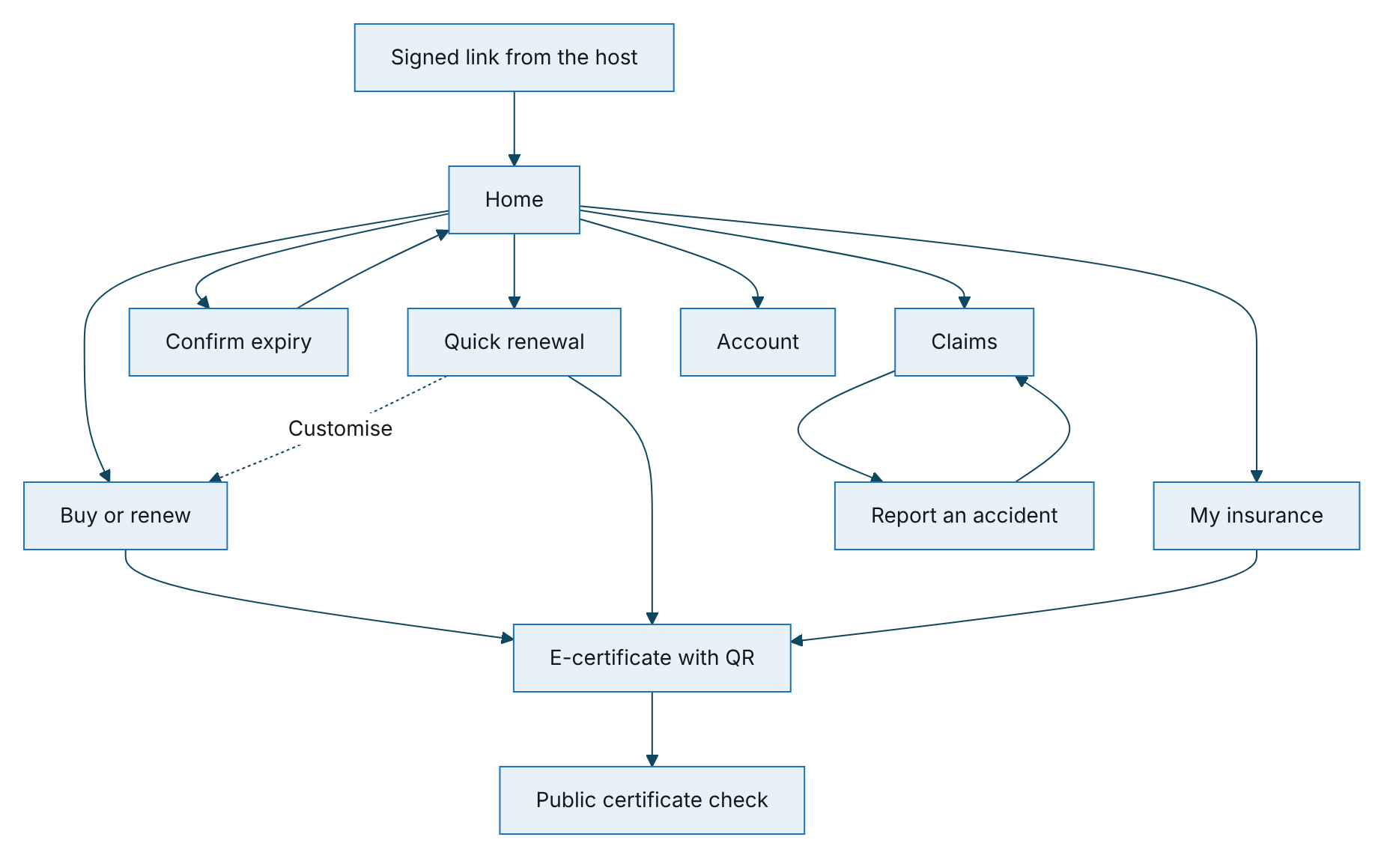
Figure 3 – Customer app map: entry, tabs and task flows

Renewal paths
A renewal follows one of two paths. The server decides which one the Home vehicle card offers, from the Quick renewal section of the Service levels rule set, and sends the decision with its reasons to the app with the Home data. The app never decides on its own.
Path | Taps from Home | Offered when
Quick renewal | 3: “Gia hạn nhanh”, the declaration tick, “Xác nhận thanh toán” | The case is eligible (rule below) and the cover is due or lapsed
Full flow | 6: “Gia hạn ngay”, “Xem phí bảo hiểm”, “Tiếp tục”, the declaration tick, “Thanh toán”, “Xác nhận thanh toán” | Every other case; always reachable through “Tùy chỉnh gói bảo hiểm”
Eligibility rule. A customer qualifies for quick renewal when all of these hold:
No. | Condition | Setting in the rules studio (Service levels › Quick renewal)
1 | Quick renewal is switched on | “Offer quick renewal”: on
2 | The lead’s journey is a renewal, or the customer is renewing a TASCO TNDS policy | “For these journeys”: Renewal
3 | The vehicle has not already been renewed | Fixed
4 | Vehicle use and seats are confirmed by TASCO core, a matching TASCO policy, or the customer within 365 days | “Vehicle use and seats must be confirmed”: on; “Customer confirmation valid for”: 365 days
5 | The cover is TNDS, with no physical damage cover | “Renew personal accident cover too”: off
6 | The price will not be indicative | Fixed
7 | In VETC hosts, the last known VETC wallet balance covers the premium | “VETC wallet balance must cover the premium”: on
The quick path keeps the same safeguards as the full flow: the declaration is still an explicit tick, the review screen shows the plate, vehicle, period, premium, total and payment method before the customer pays, and payment is idempotent. When a reason is one the customer can act on (vehicle details to confirm, wallet balance too low), Home shows it as a hint under “Gia hạn ngay”. The conditions are listed for confirmation by TASCO.

Purchase flow
The full purchase flow is the same for a renewal, a new purchase and a quote sent by telesales; a telesales quote opens directly at the review step, where the diagram starts. Payment is possible only when the quote is ready. Its decision points protect the customer: an indicative price must be confirmed by TASCO core before payment, physical damage cover needs a vehicle inspection, and a failed payment never charges the customer.

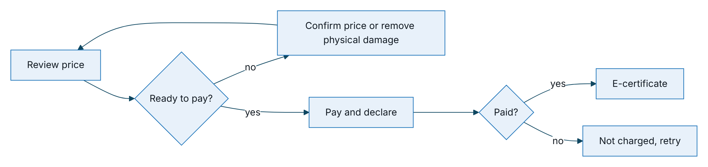
Figure 4 – Purchase flow with its decision points and failure paths

Step | Screen | Main action
1 Chọn gói | Quote form: business use, vehicle type, seats, term, optional seat accident and physical damage cover | “Xem phí bảo hiểm”
2 Xác nhận | Vehicle confirmation card, price detail with VAT, included benefits, quote validity | “Tiếp tục” (after “Xác nhận thông tin xe” if the vehicle is not yet confirmed)
3 Thanh toán | Payment method for the host, payment details, declaration tick box | “Thanh toán” with the amount, then “Xác nhận thanh toán” in the sheet
Result | Processing, then success with policy numbers and certificate, or failure with retry | “Lưu chứng nhận”, “Về trang chủ”

Claim wizard
Reporting an accident takes five short steps with a progress bar (“Bước 2/5”). The customer chooses the policy, gives the date, time and place, says what happened and whether anyone was hurt, adds photos and reviews before sending. The confirmation shows the claim reference and the acknowledgement deadline, and the claim appears in the Claims tab with its progress: Đã gửi, Tiếp nhận, Giám định, Duyệt, Chi trả. Without an active policy the wizard shows an empty state with “Mua bảo hiểm”.

Account
Account groups three things the customer controls: privacy and contact (marketing consent and call consent as switches that save at once; the policy service notices are always on), personal data (“Tải dữ liệu của tôi” downloads a copy of the data TASCO holds) and support (the same channels as the support sheet). In demo environments only, it also offers “Đổi khách hàng demo”.

Hosts
The same customer app runs in four hosts. One set of screens and services serves them all; the brand is always TASCO Insurance; the host decides the payment method and some wording.
Host | Channel value | Brand | Payment | Release
VETC app | vetc_app (default) | TASCO Insurance | Ví VETC (VETC wallet) | MVP pilot
Zalo Mini App | zalo_mini_app | TASCO Insurance | Ví VETC | Scale phase, module S4
TASCO app | tasco_app | TASCO Insurance | Thanh toán qua cổng TASCO | Scale phase, module S3
TASCO website | tasco_web | TASCO Insurance | Thanh toán qua cổng TASCO | Scale phase, module S3
All four hosts work in the sandbox today; the TASCO payment gateway is a sandbox adapter until TASCO’s integration is specified.
What changes by host:
- the footer note (“Phân phối qua ứng dụng VETC” or “Bảo hiểm TASCO”);
- the payment method on step 3, its description and the security line (“Thanh toán được bảo mật bởi VETC” or “… bởi cổng thanh toán TASCO”);
- the wallet balance and the low-balance notice, shown only for the VETC wallet, and the wallet-balance condition for quick renewal, which applies only in VETC hosts;
- every message that sends the customer back to the host (“Vui lòng mở lại từ ứng dụng VETC”, “… từ website Bảo hiểm TASCO”);
- the channel recorded on quotes and orders, which drives sales-by-channel reporting.
The brand, screens, steps, prices and wording of the insurance itself do not change.
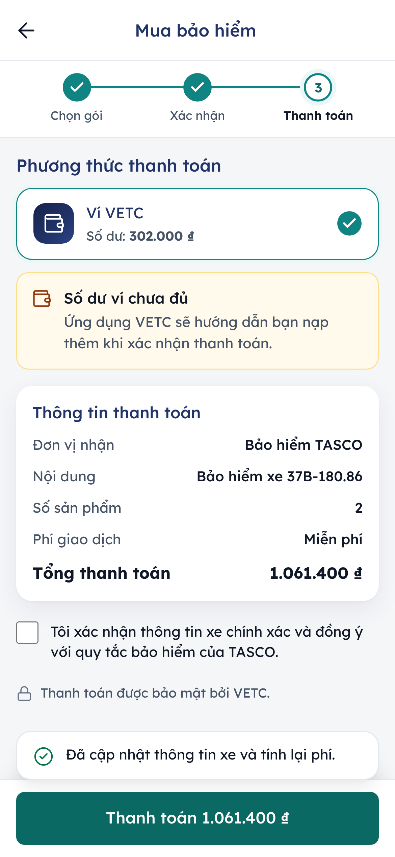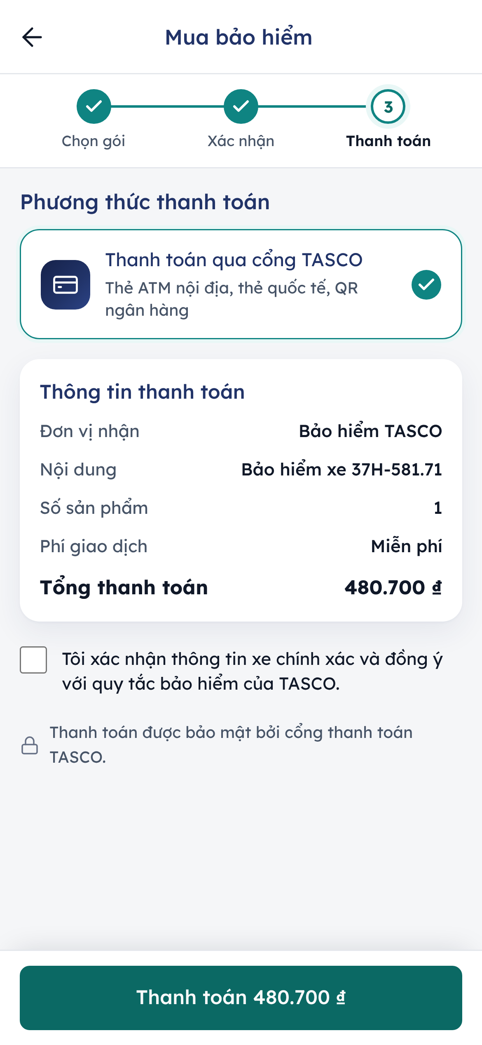
Payment step in the VETC app (VETC wallet) and on the TASCO website (TASCO payment gateway)

Deep links
Link | Opens | Rules
/app/?r=<signed token> | The customer app for one vehicle, on Home | The token names the customer profile and its expiry and is signed by the platform; it is valid for 30 days. It is exchanged for a session at once and removed from the address bar
/app/?r=<token>&channel=<host> | As above, in the named host | Only the four channel values are accepted; anything else falls back to vetc_app. The channel is kept for the session
/app/#/buy?quote=<quote> | Review step of a quote sent by telesales | Used by the Home quote card; an expired or paid quote returns to step 1 with a message
/app/#/renew-quick | Quick renewal | If the case is not eligible, the screen says why and offers the full flow
/app/#/policies, #/claims, #/claims/new, #/account, #/confirm | A tab or flow, once a session exists | Without a session the app shows the entry screen
/verify/<certificate number> | Public certificate check | Encoded in the certificate QR code; shows status, product, masked plate and period
/#/<page> and /#/customer/<id> | A console page or Customer 360 | After sign-in the user lands on the requested page if the role allows it, otherwise on the start page
Renewal links reach the customer in VETC app notifications, Zalo messages from the official account and SMS. An expired or damaged link shows “Liên kết đã hết hạn hoặc không hợp lệ” with the instruction to open the app again from the host. Opening the insurance section directly with VETC single sign-on, without a link, is part of scale module S2; until then the signed link is the way in.

Key task paths
The paths below count deliberate taps or clicks from the natural starting point; typing is not counted. They are the baseline for the usability tests in TGP-UX-04.

Customer renews from a reminder
The renewal has two paths (see “Renewal paths”). NFR-035, as restated, asks for three taps where the case allows it, six in the full flow, and a median renewal of 60 seconds or less. The usability tests in TGP-UX-04 measure both paths.
Quick renewal:
Tap | Action | Screen reached
0 | Open the link in the reminder | Home with the vehicle card, “Gia hạn nhanh” and “Tùy chỉnh gói bảo hiểm”
1 | “Gia hạn nhanh” | Quick renewal: plate, vehicle, period, premium, total, payment method
2 | Tick the declaration
3 | “Xác nhận thanh toán” | Processing, then success with the e-certificate
Full flow:
Tap | Action | Screen reached
0 | Open the link in the reminder | Home with the vehicle card and “Gia hạn ngay”
1 | “Gia hạn ngay” | Quote form with the vehicle details filled in
2 | “Xem phí bảo hiểm” | Review with the price and benefits
3 | “Tiếp tục” | Payment
4 | Tick the declaration
5 | “Thanh toán” with the amount | Confirmation sheet
6 | “Xác nhận thanh toán” | Processing, then success with the e-certificate
The full flow keeps its confirmation sheet because the customer may have changed the cover, the term or the vehicle details on the way. A quote sent by telesales opens at the review step and also takes six taps: “Xem và thanh toán”, “Xác nhận thông tin xe”, “Tiếp tục”, the declaration, “Thanh toán” and “Xác nhận thanh toán”.

Compliance officer handles a data request
Actor | Path
Compliance officer | Governance › Data requests › “Log request” › customer, type, channel, date received › “Log request”
Compliance officer | Row “Export data” (access) or “Erase personal data” (erasure) › tick the identity check if not yet recorded › “Review” › “Export and download” or “Erase permanently”
Compliance officer | Bell or the “Due within 24 h” tile › request drawer › next action, or ⋯ › “Refuse” with a reason and an explanation for the customer

Telesales agent works a handoff
Click | Action
1 | Select the handoff on My work today or in the inbox; the call brief opens beside the queue
2 | “Call customer” (assigns the handoff; the agent dials from the official hotline)
3 | “Send quote” (opens Customer 360 on Policy & quotes)
4 to 5 | Switch on an add-on and choose the cover, if wanted
6 | “Calculate price”
7 | “Send to customer’s VETC app”
8 to 11 | Back to the inbox, select the handoff, More actions, “Mark won” and confirm
The call brief and talking points are one click from the start page, which meets NFR-036. Staff never take payment; the customer pays in the app.

Rule author changes a setting and an approver activates it
Actor | Path
Rule author | Business rules › rule set › “Create draft from this version” › edit the form › “Validate” › “Run simulation” › “Save draft” › “Submit for approval” with a note
Approver | Notification or Approvals › “Review” › read what changes and the effect on customers › “Approve” › “Approve and activate”
The new version is active within seconds and the author cannot approve their own change. Restricted rule sets go to a compliance officer.

Appendix

Customer app screen inventory
Screen | Route | Bar | Support button
Entry (splash) | /app/ without a session | None | No
Home | #/home | Tab bar | Yes
My insurance | #/policies | Tab bar | Yes
Claims | #/claims | Tab bar | Yes
Account | #/account | Tab bar | Yes
Quick renewal | #/renew-quick | Action bar | No
Buy or renew | #/buy | Action bar | No
Confirm expiry | #/confirm | Action bar | Yes
Report an accident | #/claims/new | Action bar | Yes
Certificate check | /verify/<certificate number> | None | No

Page names in both languages
English | Tiếng Việt
Sell, Engage, Serve, Partners, Data, Governance, Administration | Bán hàng, Tương tác, Dịch vụ, Đối tác, Dữ liệu, Quản trị, Quản trị hệ thống
Dashboard | Tổng quan
Leads | Khách hàng tiềm năng
Telesales inbox | Hộp việc telesales
Voice assistant | Trợ lý gọi tự động
Journeys, Campaigns | Hành trình, Chiến dịch
Claims | Bồi thường
Data quality | Chất lượng dữ liệu
Business rules, Approvals, Audit | Quy tắc nghiệp vụ, Phê duyệt, Nhật ký kiểm toán
Data requests | Yêu cầu dữ liệu (page title: Yêu cầu dữ liệu cá nhân)
Users, Operations | Người dùng, Vận hành
Customer 360 | Khách hàng 360

Sign-Off
Serial Number | Description | Owner | Status
1 | Sidebar groups and page names (English and Vietnamese) accepted as the navigation for production | TASCO Product Owner | Open
2 | Navigation and start page per role confirmed against the production role list | TASCO IT Security | Open
3 | Quick renewal eligibility conditions confirmed (journey or TASCO TNDS renewal, vehicle use and seats confirmed within 365 days, TNDS only, no indicative price, VETC wallet balance) | TASCO Product Owner and TASCO Compliance | Open
4 | Hosting of the customer app in the TASCO app and on the TASCO website (scale module S3) and in the Zalo Mini App (S4) confirmed, with the link format each host will use | TASCO IT and VETC Product Owner | Open
5 | Renewal link validity of 30 days confirmed | TASCO Compliance | Open

Sign Off Date | Signature | Approved By | Department & Project Role
 |  | TASCO Insurance | Programme Sponsor
 |  | TASCO Insurance | Product Owner
 |  | iorta TechNXT | Business Analysis and User Experience



